**IST 471**

**Lab 4 (30 Points)**

**Basics of Windowing - Partitioning**

**Team Members & Contribution % (100% - FULL CONTRIBUTION)**

|  |  |
| --- | --- |
| NAME | CONRIBUTION % |
| Ethan Flores | 100% |
| Manny B. Tapia | 100% |
| Alexa Schnetzler | 100% |
| Tyler Brown | 100% |
| ??? |  |
| ??? |  |

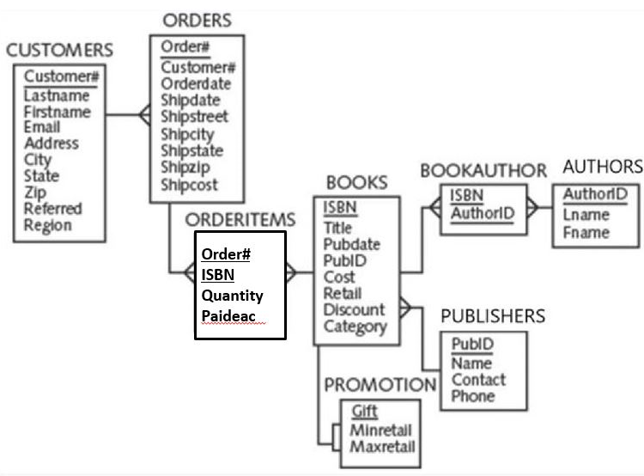

**Problem 1.** Compute the running/cumulative sum of cost for all books. Sort the results in ascending order of ISBN.

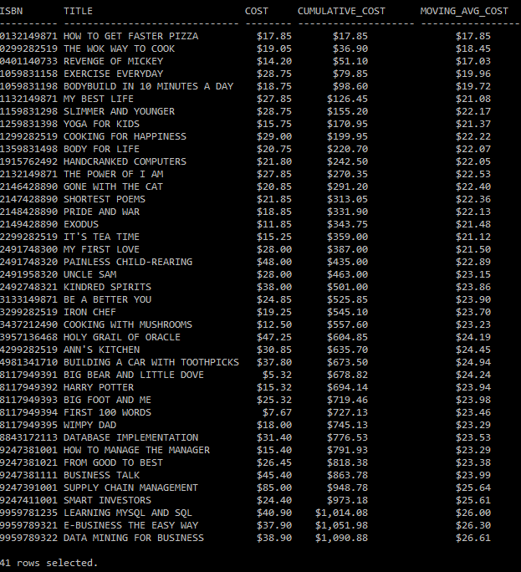

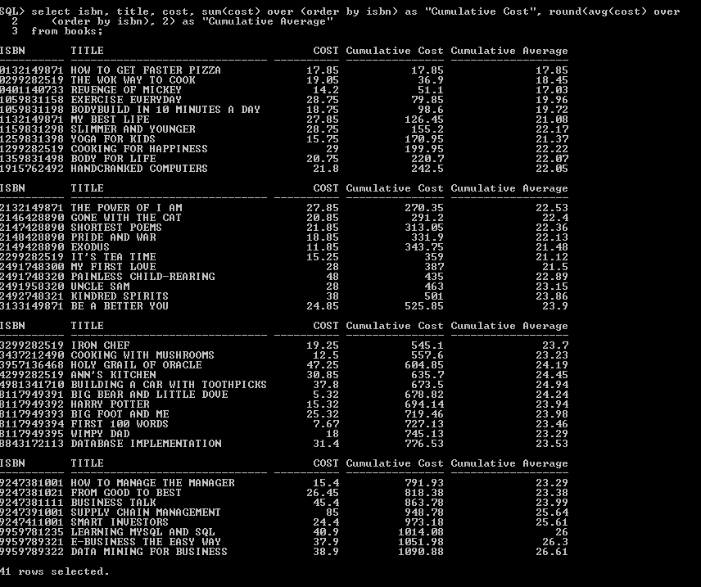

**Problem 2.** Compute the cumulative sum of quantity for all orders. Sort the results in ascending order of customer's name and order#. YOU SHOULD ALSO INCLUDE THOSE CUSTOMERS WHO DID NOT MAKE ANY ORDER IN THE PAST. (amount due = quantity * paideach)

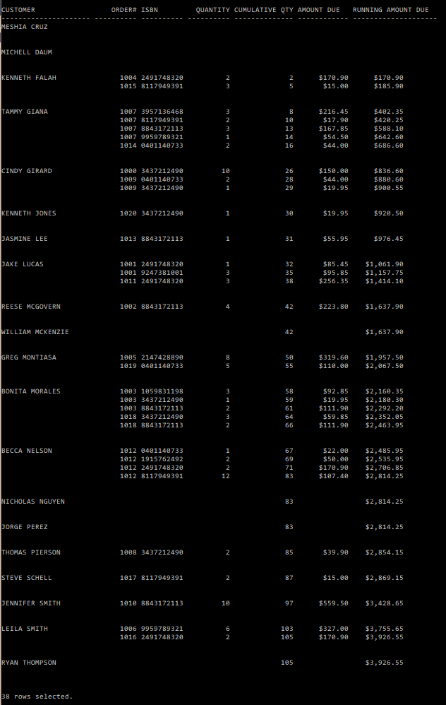

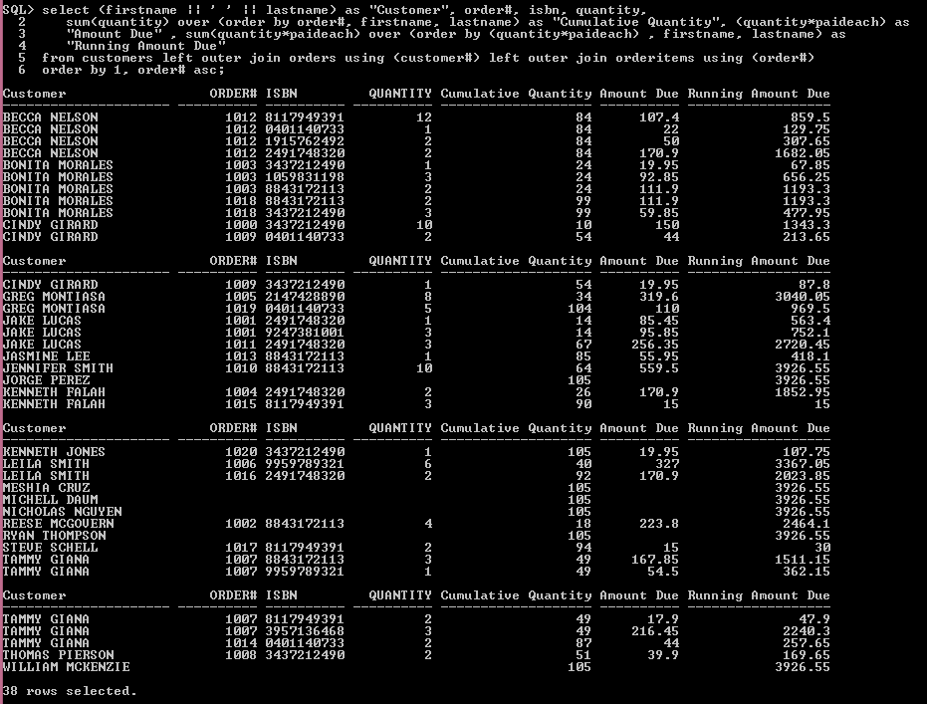

**Problem 3.** Compute the running sum of quantity and amount due for EACH order. INDICATE 'NO ORDERS' FOR THOSE CUSTOMERS WHO DID MAKE ANY ORDER.

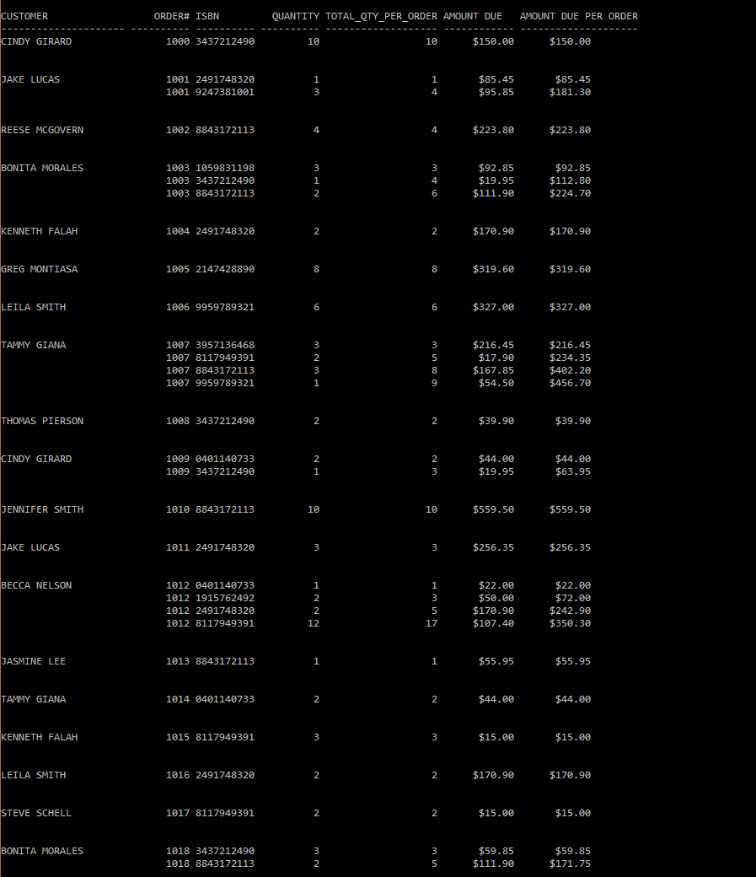

Continue on page …

